24780 Engineering Computation: Problem Set 5

Balasubramanyam Evani

AndrewId: bevani

1. **How to use your program?**

* Compile and run the binary.
* 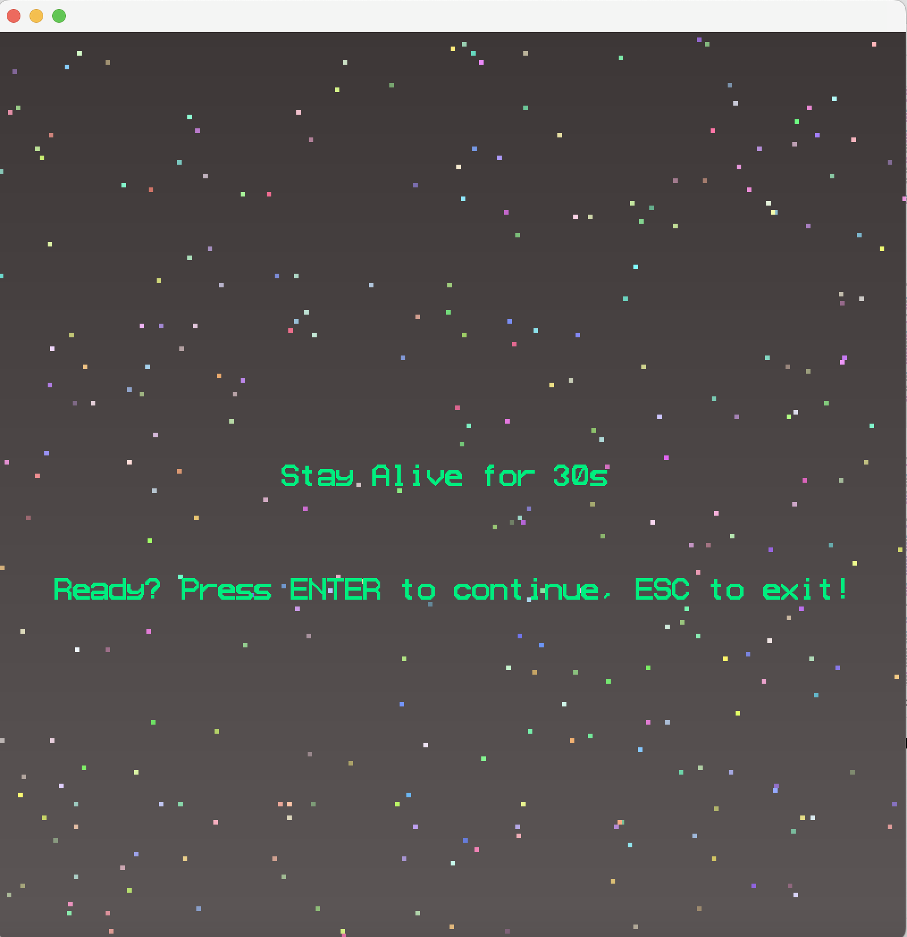The user will be shown the below screen.
* The goal of the game is to stay alive (in a spaceship) for 30 seconds.
* If the user presses exit, the app closes with exit status 0.
* If the user chooses to play by pressing ENTER, then the game screen is now displayed to the user which will look something like below.

* The spaceship is equipped with 3 hyper beams which can go through any number of meteors hurling towards the spaceship.
* The goal of the player is to maneuver (using only KEY_LEFT and KEY_RIGHT) and use KEY_SPACE to shoot beams to keep the spaceship alive for 30s.
* Any hit to the spaceship by a meteor is fatal, and the game will end.
* The meteors can bounce off each other.

**Please note** that the game could be made more exciting by increasing the required survival time to more than 30 seconds. However, for the sake of the assignment's scope, I didn't do so, as the focus was to display the techniques learned in class.

1. **Which features you used for satisfying the above requirements.**

* OpenGL Animation using Double Buffering
* Animation runs in a for loop until user wants to terminate by pressing ESC Key or the game terminates.
* Game is interactive, user can shoot beams and maneuver the spaceship.
* Used Color gradation for the background and meteor color.
* Used Primitives: GL_POINTS, GL_POLYGON, GL_TRIANGLE_FAN, GL_QUADS.
* Used math library function for
  + Collision detection
  + Drawing circles